Contents
1. Project Rationale 1
1.1 Problem Description 1
1.2 System Explanation 2
1.3 Structured Programming Application 2
1.4 SDG Relevance 3
2. System Architecture & Key Modules 3
2.1 Role-Based Access 3
2.2 Data Persistence 3
3. Source Code Extracts 4
3.1 Book Request Function (app/logic.py) 4
3.2 Student Registration with Auto-Generated ID (app/logic.py) 4
4. Screenshots 5
5
5
5. Open Source, Data Privacy & Compliance 6
5.1 Open Source 6
5.2 Data Accessibility & Interoperability 6
5.3 Privacy & Ethical Use 6
6. Conclusion 6

1. Project Rationale

1.1 Problem Description
Public and school libraries across Sierra Leone, including those operated by Limkokwing University, still rely heavily on paper registers and manual ledgers to track books, borrowers, and due dates. This manual approach is slow, error-prone, and makes it almost impossible to know in real time which titles are available, who is holding which book, or which loans are overdue. Students frequently lose time queuing at the librarian's desk simply to ask whether a book is on the shelf, and librarians spend hours reconciling handwritten records instead of supporting readers.
LibrarySys was developed to digitize this entire workflow. It is a desktop GUI application, built in Python using the tkinter library, that allows a librarian or administrator to maintain a digital catalog of books, register students with an automatically generated Student ID, and manage a complete request-approval-issue-return cycle. Students can browse the catalog, request an available title, and immediately see in their own dashboard when that book has been approved and assigned to them, removing the need for repeated front-desk visits.

1.2 System Explanation
LibrarySys is organised around three account roles — Administrator, Librarian, and Student — each restricted to the pages relevant to their responsibilities through a role-based access control list. The core workflow is as follows:
- An Administrator or Librarian adds books to the catalog (title, author, ISBN, category, number of copies).
- An Administrator or Librarian registers a new student; the system automatically generates a unique Student ID (e.g. STU0001) and a starting password, rather than relying on manual ID assignment.
- A logged-in Student browses the catalog and submits a request for a book that currently has available copies. Books with zero available copies cannot be requested.
- An Administrator or Librarian reviews pending requests on the Book Requests page and approves or rejects each one. Approval automatically issues the book, decreases the available-copy count, and creates a due date 14 days from the issue date.
- The Student immediately sees the book under "Books Currently Assigned to Me" on their personal dashboard, together with the due date.
- When finished, the Student returns the book from the same dashboard (or a Librarian processes the return); the available-copy count is restored and the book becomes requestable again.
- The system tracks overdue loans automatically by comparing the due date with the current date every time data is displayed.
The application also provides a statistics dashboard (titles, copies, loans, overdue counts, category breakdown), a full borrow-history page for staff, a CSV/report export feature, an activity log that records every action performed in the system together with who performed it, and full user-account management for administrators.

1.3 Structured Programming Application
The project strictly separates concerns into independent, reusable modules so the program can be understood, tested, and extended one piece at a time:
- config.py — holds constants only (colours, role permissions, navigation list, default accounts); no logic or GUI code.
- data_store.py — owns all in-memory data structures and is the only module that reads or writes the data.json file, using an atomic write to prevent corruption.
- logic.py — every business rule (validation, ID generation, issuing, returning, requesting, approving, statistics) lives here as a pure function with no tkinter import, so it can be tested independently of the interface.
- gui/ (login_window.py, main_app.py, pages.py) — builds the window, sidebar, and individual pages, and calls into logic.py rather than manipulating data directly.
Within these modules, the required structured-programming elements are demonstrated throughout: constants and variables (e.g. LOAN_PERIOD_DAYS, ROLE_PERMISSIONS), explicit data types (strings for IDs, integers for copy counts, dictionaries/lists for records), decision structures (if / elif / else used for every validation and access-control check), iteration (for loops used to search books, sweep overdue loans, and rebuild every table the GUI displays), and well in excess of three user-defined functions — the logic module alone defines more than thirty, including add_book(), issue_book(), return_book(), register_student(), request_book(), approve_request(), and reject_request().

1.4 SDG Relevance
LibrarySys is aligned principally with SDG 4 – Quality Education, by making library resources easier to discover, request, and track, which directly supports access to books and learning materials for students. It also touches SDG 9 – Industry, Innovation and Infrastructure, by replacing a manual paper-based process with reusable, open-source digital infrastructure that any school or community library in Sierra Leone could adopt at no licensing cost, and SDG 11 – Sustainable Cities and Communities, by strengthening a shared community institution (the library) through better, more transparent resource management.

2. System Architecture & Key Modules
The table below summarises the responsibility of each file in the codebase.
File | Responsibility
main.py | Application entry point; loads saved data and launches the login window.
app/config.py | Application-wide constants, role permissions, and navigation structure.
app/data_store.py | In-memory data lists/dicts and atomic JSON save/load.
app/logic.py | All business logic: books, transactions, requests, students, users, reports.
app/gui/login_window.py | Login screen and authentication.
app/gui/main_app.py | Application shell: header, sidebar, routing, access control.
app/gui/pages.py | All page content: dashboard, catalog, manage books, register student, requests, issue/return, history, reports, activity log, user management.

2.1 Role-Based Access
- Administrator: full access — dashboard, catalog, manage books, register students, book requests, issue/return, history, reports, activity log, user management.
- Librarian: same as Administrator except cannot manage user accounts.
- Student: dashboard, catalog (with Request button), and a personal "My Books" page (current loans, request status, full history, return button).

2.2 Data Persistence
All books, transactions, requests, the activity log, and user accounts are written to data.json after every change using an atomic temp-file-then-replace strategy, so the application can be closed and reopened without losing data.

3. Source Code Extracts

3.1 Book Request Function (app/logic.py)
def request_book(student_id, book_id, performed_by="Unknown"):
account = USER_ACCOUNTS.get(student_id)
if account is None or account.get("role") != "Student":
return False, "Only registered students may request books."
book = get_book_by_id(book_id)
if book is None:
return False, "Book not found."
if book["available_copies"] <= 0:
return False, f"'{book['title']}' has no available copies right now."
...
requests_data.append(record)
save_data()
return True, f"{request_id}: request submitted. Awaiting approval."

3.2 Student Registration with Auto-Generated ID (app/logic.py)
def register_student(full_name, performed_by="Unknown"):
student_id = generate_student_id() # e.g. STU0001
while student_id in USER_ACCOUNTS:
student_id = generate_student_id()
password = student_id
USER_ACCOUNTS[student_id] = {
"password": password, "role": "Student", "full_name": full_name
}
log_activity(student_id, full_name, "Student Registered", performed_by)
save_data()
return True, f"Student registered. ID: {student_id}", student_id

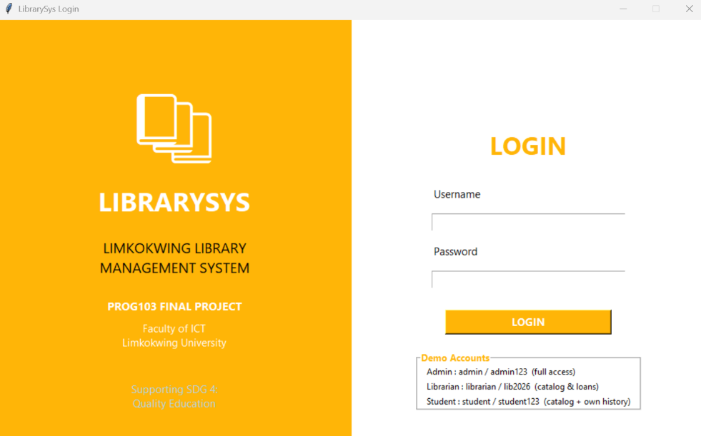
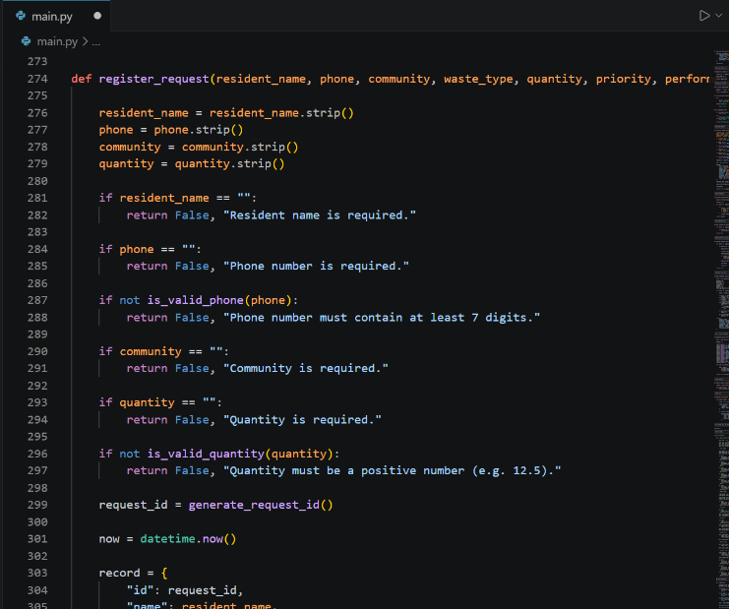
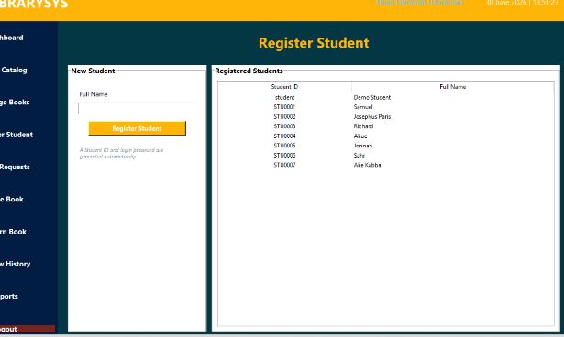
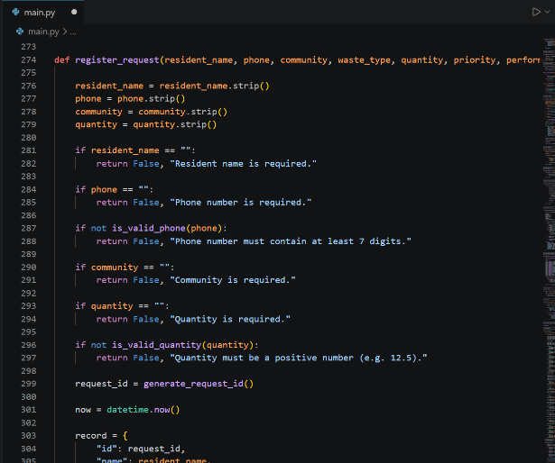
4. Screenshots

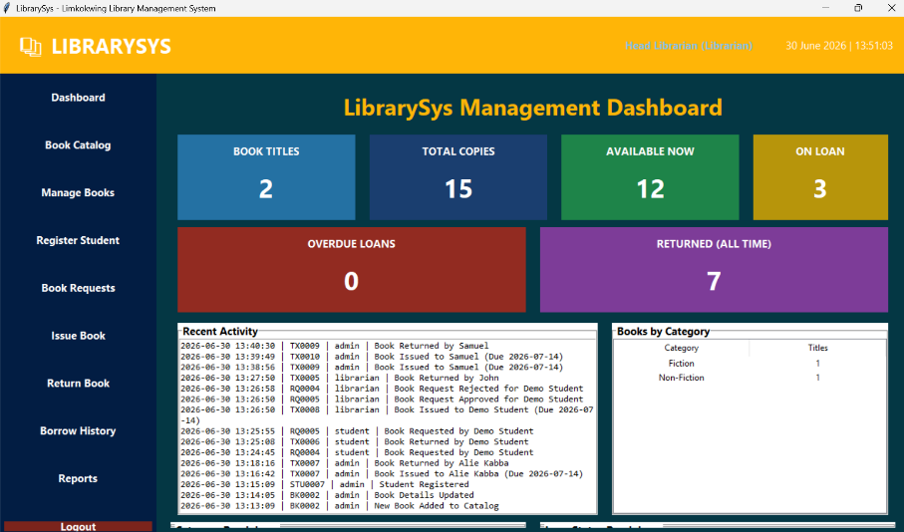
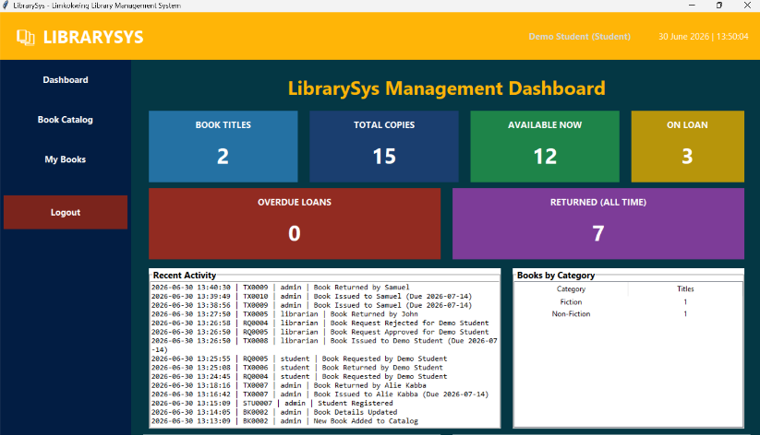

5. Open Source, Data Privacy & Compliance

5.1 Open Source
- Project published on GitHub with a public repository.
- Licensed under the MIT License (see LICENSE file) — free for any school or library to reuse and adapt.
- Repository includes README.md, this documentation, and screenshots as required.

5.2 Data Accessibility & Interoperability
- All records are stored in a single human-readable data.json file using standard JSON, so data can be opened, audited, or imported into other systems without proprietary tools.
- Catalog and transaction data can be exported to CSV at any time for use in spreadsheets or other library systems.

5.3 Privacy & Ethical Use
- Only the minimum personal data needed to operate a library (full name and an auto-generated Student ID) is collected — no sensitive personal data is requested.
- Passwords are required at login and the system enforces a minimum password length; only Administrators can create or remove accounts.
- All sensitive actions (book issued, returned, request approved/rejected, account created/deleted) are written to an immutable activity log identifying who performed the action, supporting accountability.

6. Conclusion
LibrarySys demonstrates how the core principles of structured programming — modular separation of configuration, data, logic, and interface; consistent use of decision structures and loops; and a clear library of well-named functions — can be combined with a practical tkinter GUI to solve a genuine, everyday problem facing libraries in Sierra Leone. By automating student registration and the book request-approval-return cycle, the system reduces manual paperwork, gives students instant visibility of their own loans, and gives library staff an accurate, real-time picture of the collection, directly supporting SDG 4's goal of improving access to quality educational resources.

